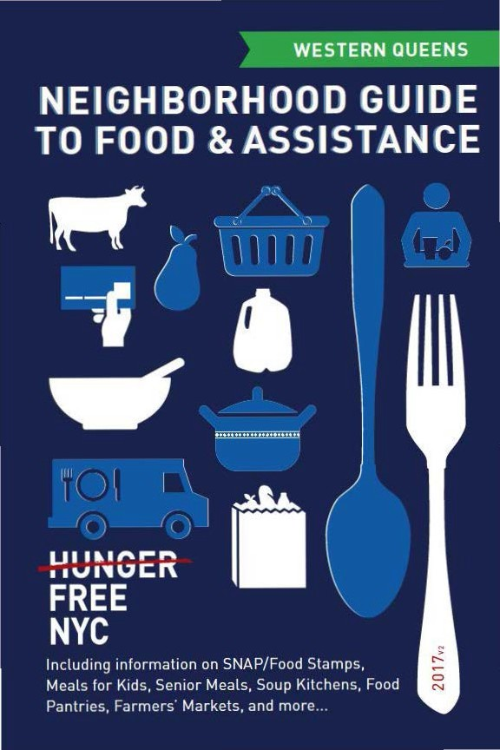

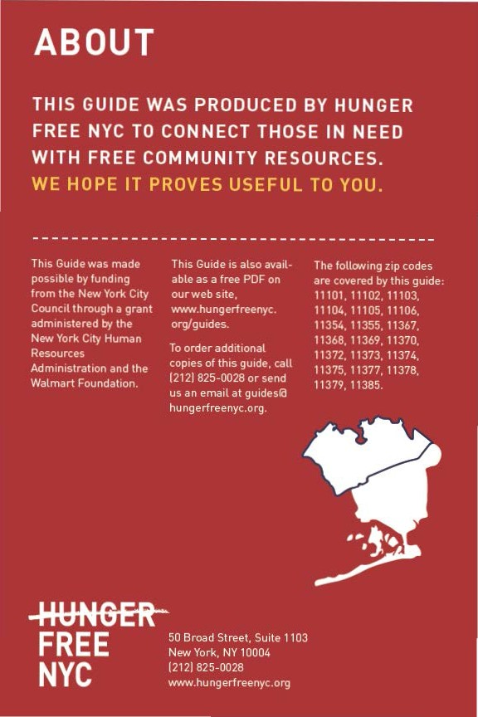

CON TEN TS

Food Stam ps/SNAP 4
6) Food fo r Kids 8
(I) Seni or Meals 1 1
0- Soup Kitchens & Food Pantries 12
e From the Fa rm 20
9 Em ployme nt & Tra in ing 23
Map of Locations 24
Other Assista nce 30
Emergency N um bers 31

Neighborhood Guide to Food andAssistance - Western Queens Edition
 SNAP/
FOOD STAMPS
SNAP benefits, the new name for food stamps, can help put healthy food on the table by providing monthly assistance
to purchase food at authorized grocery stores and farmers' markets. Benef its are provided monthly th rough a plastic benef it card, similar to a de bit or credit card.



EBT
Stands for Electronic Benefit Transfer. It's the system the goverment uses to disburse benefits.

SNAP
Stands for
Supplemental Nutrition Assistance Program. "SNAP benefits" is the same thing as ..food stamps."

WHAT SHOULD I KNOW?

ID Employment does not interfere with getting SNAP.Even if you a re working, but earning lowwages, you may be eligible.
ID Average SNAP benefits a re over $100 per person per month, and $250 or more
for families. That mea ns that SNAP benef its for the average family receiving them totals more than $3,000 worth of food support
each year.
ID Farmers' markets often accept SNAP benefits, so you ca n purchase fresh produce and food-producing seeds and plants using your benefits. For a complete list of farmers' markets that accept them , see page 20.

IINeighborhood Guide to Food and Assistance ·Western Queens Edition

AM I ELIGIBLE?


Eligibilit y is based on household size, income, expenses and other factors. Households have to meet income tests to receive benefits, but households that have members w ho are disabled or elderly (60 or older), or have out-of-pocket expenses for
.
child care or dependant ca re, ca n have higher incomes a nd still be eligible.

NUMBER OF PEOPLE
A
MONTHLY INCOME LIMIT
1
IN HOUSEHOLO | (PRE-TAXES] |  | SNAP BENEFITS
1 | $1 ,307 |  | $192
2 | $1 ,760 |  | $352
3 | $2,213 |  | $504
4 | $2,665 |  | $640

MAX.MONTHLY
2

Each additional household member
+$453
(approximately)
+ $144
(approximately)

11n effect
10/1/16 - 9/30/17.

21n effect
10/1/16 - 9/30/17.

If you meet the above income qualifications, it doesn't matter how much money you may or may not have in countable resources. In other words, you can save money for education , a home purchase, or retirement a nd still receive SNAP benefits.

Neighborhood Guide to Food andAssistance - Western Queens Edition II

IMMIGRANT ELIGIBILITY

Legal immigrants can often receive SNAP benefits if they:
- have lived in the country for 5 years or more; or
- are children (under age 18).
Ineligible immigrant parents can still receive benefits for their children even if a parent does not qualify.
Certain non-citizens, such as those admitted for humanitarian reasons, may also be able to receive benefits.
Immigration status is not negatively affected if you apply for or receive SNAP benefits.

HOW TO APPLY

Apply at Select Community Organizations
1

Call either of the below numbers to see if you may be eligible for benefits. If so, you’ll be offered an appointment at an agency in your community, where you’ll receive help in submitting your application electronically.
Hunger Free NYC
646 355 1475 & 646 350 1104

Neighborhood Guide to Food and Assistance - Western Queens edition
6

ACCESSNYC
2
SNAP/FOOD STAMPS

Apply online at: www.nyc.gov/accessnyc

Visit Your Local HRA Office
3

Apply at a SNAP office near you:
1 Queens snAP Center
32-20 Northern Blvd., 2nd Floor, 11101 (entrance on Honeywell St.)
718 722 8013
Mon-Fri 8:30am-5pm

You can also call 718 557 1399 to find a SNAP office near you and for information about qualifications, guidelines, and applications.

Neighborhood Guide to Food and Assistance - Western Queens edition
7
I)FOOD FOR KIDS
WOMEN, INFANTS & CHILDREN
WIC is the Women, Infants & Children Program.
QUICK FACTS
ID WIC is for low-income pregnant women, breast-feeding women, and women with children under the age of five.
ID You can work and still get WIC.
ID You can continue to get cash assistance or SNAP benefits/food stamps while receiving WIC.
ID You can get WIC even if you are undocumented or not a citizen.

HOW TO APPLY
To find the WIC off ice nearest you call 800 522 5006, call 866 3-H UNG RY or v isit these local WIC off ices.

- Public Health Solutions Astoria WIC Center 12-26 31st Avenu e, 11106
718 726 5816
Mon-Sat 8:30am-4pm
- Bellevue - Sunnyside WIC 49-02 Queens Blvd.. 11377
718 779 8828
Mon 9am-6pm; Tue,Wed, Fri 9am-5pm; Thu 8am-5pm; 2nd Sat 8am-3:30pm by appt. only
- Catholic Charities Woodside WIC Site 42-71 65 Place, 11377
718 715 7001
Mon-Fri Bam-4:30pm, Sat once/month by appt. only

IINeighborhood Guide to Food and Assistance· Western Queens Edition
- elmhurst Hospital Center 81-06 Baxter Ave, 11373 718 334 3265
FOOD FOR KIDS
Mon, Wed, Fri 8am-4:30pm (last appt. 3:30pm); tue, thu 10am- 6pm (last appt. 5pm)
- Public Health solutions Corona WIC Center
103-24 Roosevelt Ave., 3rd Floor, 11368
718 335 7563
Mon 11am-6:30pm; tue-sat 8:30am-4pm
- urban Health Plan - Plaza del sol Family Health Center WIC
37-16 108th St., 11368
347 686 3700 x 5580
Mon, thu, Fri 9am-5pm; tue 8am-5pm; Wed 8am-6pm; every other sat 8am-4pm
- Public Health solutions Flushing WIC Center
42-60 Main Street, 11355
718 961 6381
Mon 11am-6:30pm; tue-sat 8:30am-4pm
- Jamaica Hospital - Flushing Medical Center
45 Ave. at Parsons Blvd., 5th Fl., 11355 718 670 5277
Mon-Fri 8:30am-5pm
- Public Health solutions ridgewood WIC Center
55-05 Myrtle Ave., 3rd Fl., 11385
718 381 8343
Mon 11am-6:30pm; tue-sat 8:30am-4pm

Neighborhood Guide to Food and Assistance - Western Queens edition
9
sCHOOL & suMMer Me ALs

sFsP is the Summer Food Service Program, also known as Summer Meals.
QuICK FACts
During school, free breakfasts are available to all children regardless of income, with no paperwork required.
Many public school students are also eligible for free or reduced price lunch. An application may be required.
Eligibility for school meals is not impacted by immigration status.
In June, July and August, lunch and breakfast are served for free to all children under 19 at many public schools, houses of worship, recreation centers, and community centers - no application or registration required.
Visit www.schoolfoodnyc.org for more information about school breakfast, school lunch, and summer meals. For nearby summer meals sites, text FOOD to 877-877, call 311, or call the National Hunger Hotline at 866 3-HUNGRY.

Neighborhood Guide to Food and Assistance - Western Queens edition
10

eSENIOR MEALS
MEALS AT SENIOR CENTERS
Senior centers often serve meals for older people. Some centers offer free meals, oth ers ask for a small contribution !from fifty cents up to a few dollars!. This contribution may be voluntary or required. Senior cen ters and other sites with food for seniors are marked with • in the Soup Kitchens and Food Pantries section.
FIND YOUR LOCAL SENIOR CENTER
Call 311 and be prepared to provide your ZIP code to the operator.

MEALS- ON- WHEELS PROGRAM
If you are homebound and over the age of 60, you can receive home-delivered meals up to 7 days a week. Household income does not
affect eligibility.
HOW TO APPLY
To request meals-on-wheels service , call yourlocal case management agency.
To find the appropriate agency, contac t the Citymeals-on-Wheels' Program Department at 212 687 1234 or the National Hunger Hotline at 866 3-HUNGRY.
Neighborhood Guide to Food andAssistance - Western Queens Edition
OUP KITCHENS OFOOD PANTRIES
Agencies listed as sou p kitchens provide prepared meals during
their listed serving times, wh ile agencies listed as food pantries provide bags of food to be prepared at home.
Whilewe try to keep this list as accurate and up-to-date as possible, we recom mend calling the agency before going to confirm their schedule. Some agencies require a referral, I D, or proof of address. To conf irm, contact the agency directly, call the NYC Emergency Food Line at 866 888 8777 or call the National Hu nger Hotline at 866
3HUN GRY. Agencies ma rked with •are senior centers and/or provide food specifically for seniors.
LONG ISLAND CITY, ASTORIA , DITMARS
11101-11104
- St. Raphael's Food Pantry
35-20 Greenpoint Ave., Rectory basement, 11101 718 729 8957
Food Pantry:Thu 10:30a m-12pm, Sat 1 :30pm -3pm.
Photo I D required 1st time. Dry food only. Can come twice/month.
- City Harvest Queensbridge Mobile Market
Basketba ll court behind 10-25 41 st Avenue, 11101 646 412 0600
Mobile Market Pantry: 2nd Tue, 4th Sat 9:30am-11 :30am Residents of the Queensbridge, Ravenswood Houses and members of the Jacob Ri is Settlement House. All food is fresh fruits and vegetables. Families must register to part icipate -
bring proof of address and a photo ID. For further information on
reg istration please call 646 412 0743. For inform ation on available produce and dates of distribution, please call the Mobile Market
H otline at 866 444 0244.
II
Neighborhood Guide to Food and Assistance - Western Queens Edition
- Catholic Charities st. Patrick
PANTRIES & KITCHENS
39-38 29th Street, 11101
347 731 1065
Food Pantry: 2nd sat 10am-12pm
- Iglesia Alianza Cristiana Misionera ebenezer
43-02 38th St., 11101
718 729 1944
Food Pantry: sat 11am-12pm, sun 3pm-4pm
- sunnyside Community services
43-31 39th Street, 11104
soup Kitchen: Mon-sat 12pm-1pm For seniors (60+) only.
- Hour Children Food Pantry
In parking lot on 11th St. between 36th & 37th Avenues (look for a green awning towards right), 11106
718 482 8226
Food Pantry: Mon 2pm-4pm, tue 10:30am-12:30pm, thu 3pm- 5pm
Call before going. photo ID and proof of address required first visit. Bring your own bag.
- Goodwill tenant Association Inc.
4-21 27th Ave, Community Room, 11102
718 932 4200
Food Pantry: tue 2pm-4pm, seniors only; Fri 2pm-4pm open to all
Photo ID with address required.
- st. Margaret Mary Church Food Pantry
9-18 27th Ave., 11102
718 721 9020
Food Pantry: tue, Wed, Fri 11am
Photo ID and proof of address required. Serves residents of 11102.
- Catholic Charities Queens north Community Center
23-40 Astoria Blvd., 11102
718 726 9790
Food Pantry: tue, Fri 9:30am-12pm
ID required for all household members.
13
Neighborhood Guide to Food and Assistance - Western Queens edition
- City Harvest Astoria Mobile Market
Basketball court in Astoria Houses (4-20 Astoria Blvd.), 11102 646 412 0600
Mobile Market Pantry: 1st sat, 3rd thu 9:30-11:30am Residents of zip code 11102 and Astoria Houses only. All food is
fresh fruits and vegetables. Families must register to participate
- bring proof of address and a photo ID. For further information on registration please call 646 412 0743. For information on available produce and dates of distribution, please call the Mobile Market Hotline at 866 444 0244.
- st. Joseph roman Catholic Church
43-19 30th Avenue, 11103 Food Pantry: thu 8am-9:30am ID required.
- new York school of urban Ministry
31-65 46th Street, 11103
718 204 6471
Food Pantry: Fri 10am-12pm ID preferred.
- salvation Army Astoria Food Pantry
45-18 Broadway, 11103
718 721 9046
Food Pantry: Wed 8am-10am
ID and proof of address required.
sunnYsIDe, WOODsIDe, COrOnA, eLMHurst, JACKsOn HeIGHts, FLusHInG
11377, 11369, 11372, 11368, 11373, 11354, 11355, 11357
- st. teresa Church saint Vincent DePaul society
50-20 45th Street, 11377
718 784 2123
Food Pantry: tue 6pm-7pm
- Blessed Virgin Mary/st. Mary's Church Winfield
70-31 48th Ave, 11377
Food Pantry: thu 9:30am-12pm

Neighborhood Guide to Food and Assistance - Western Queens edition
14
- ACQC (AIDs Center of Queens County), Woodside
PANTRIES & KITCHENS
62-07 Woodside Ave., 3rd Floor, 11377
718 472 9400
Food Pantry: tue, thu 10am-12pm
Arrive early to get a ticket.. Photo ID required.
- st. John's Bread and Life Mobile soup Kitchen - Woodside
65th & Broadway, 11377 718 574 0058
Mobile soup Kitchen: tue 9:30am-11am
- Corpus Christi Food Pantry
31-31 60 Street, 11377
718 278 8114
Food Pantry: Wed 11am-1pm
Photo ID and proof of address required for first visit.
- Atonement Lutheran Church
30-61 87th St., 11369
718 639 6074
Food Pantry: thu 9am-10am www.alcqueens.com
- First Baptist Church
100-10 Astoria Blvd., 11369
718 446 0200
soup Kitchen: Wed 12pm-2pm Food Pantry: sat 12pm-3pm Closed in July and August.
- st. Mark AMe Church - the Voices of Hagar Food Pantry
95-18 Northern Blvd., 11372
718 205 0506
Food Pantry: tue 12pm-3pm
Closed July and Aug, reopens after Labor Day. Photo ID required; will be served without first time but must bring one next time.
- salvation Army-Queens temple
86-07 35th Ave., 11372
718 335 3693
soup Kitchen: tue-thu 12pm-1pm
Food Pantry: Wed 9am-10am
ID and proof of address required for pantry.
15
Neighborhood Guide to Food and Assistance - Western Queens edition
- Mt. Olivet Gospel Church
33-27 97 St., 11368
718 478 0780
Food Pantry: Wed 5:30pm-6:30pm
ID required, bring bags, client choice.
- elmcor Youth & Adult Activities Inc
107-20 Northern Blvd., 11368
718 651 0096
Food Pantry: Wed 1pm
Tickets distributed 6am-7am. No ticket required if you have a referral. First 50 people served.
- Mt. Horeb Baptist Church 109-20 34th Ave., 11368 718 639 9066
soup Kitchen: tue 12pm-2pm
- Corona sDA Church
35-30 103rd Street, 11368
718 429 7050
soup Kitchen: sun 12pm-2pm
Food Pantry: Mon 9am-11am
- evangelical Church Christ is the Light, Inc
89-16 48th Ave, 11373
347 742 7614
Food Pantry: Fri 9am-11am
Pantry is client choice. Bring your own bag.
- new Life Food & Clothing Pantry
82-10 Queens Blvd, 11373
718 424 0122
soup Kitchen: tue, thu 6pm-8pm, sat 10am-12pm
Food Pantry: tue 6pm-8pm, sat 10am-12pm
Photo ID required. Soup Kitchen for homeless. Inside New Life Fellowship Church, located in Old Elks Club.
- Jewish Institute of Queens
60-05 Woodhaven Blvd., 11373
718 426 9369 x229
Food Pantry: Fri 10:30am-12pm

Neighborhood Guide to Food and Assistance - Western Queens edition
16
- La Jornada
PANTRIES & KITCHENS
135-32 38th Ave., 11354
917 880 5693
soup Kitchen: sat 12pm-2pm Food Pantry: Wed 1pm-3pm ID required after first visit.
- south Asian Council for social services (sACss) south Asian Food Pantry
143-06 45th Ave., 11355
718 321 7929
Food Pantry: Fri 11am-4pm
- st. Michael's Church Food Pantry
136-76 41st Ave., 11355
718 353 4180
Food Pantry: tue, Wed 9:30am-12pm, thu 9:30am-1pm
- Murray Hill neighborhood Association/emmanuel Community Church
150-20 Barclay Ave., 11355
718 762 5905
Food Pantry: sat 11am-12pm Entrance at 41-54 Murray St.
- Grace episcopal Church/Flushing JCC Food Pantry
14-15 Clintonville St., 11357
718 699 1010
Food Pantry: Mon 5pm-6pm, Fri 10am-11am
rIDGeWOOD, MIDDLe VILLAGe, MAsPetH, reGO PArK,
FOrest HILLs
11375, 11374, 11367, 11385
- Forest Hills senior Center/Queens Community House
108-25 62nd Drive, 11375
718 699 1010
Food Pantry: thu (except 1st Thu of month) 8:30am-9:30am Only for those disabled, on Medicaid, or unemployed and their children.

Neighborhood Guide to Food and Assistance - Western Queens edition
17
- Catholic Charities Our Lady of the Angelus
63-63 98th Street, 11374
718 897 4444
Food Pantry: 1st sat 10am-11:30am
- Masbia of rego Park
98-08 Queens Blvd., 11374
718 972 4446
soup Kitchen: sun-thu 2pm-5pm (dinner to go)
Food Pantry: Fri 7am-11am Meals are Kosher.
- Central Queens Y/esther Grunblatt russian service Center 66-05 108th St. (early 2017)/67-09 108 St. (later 2017), 11375 718 268 5011
Food Pantry: every other Wed 9am-2pm
Emergency food available other days 9am-2pm at 67-09 108th St. Bring proof of need such as Medicaid card, EBT card, proof of unemployment. Call to confirm location.
- Kehilat sephardim of Ahavat Achim
150-62 78 Rd., 11367
718 591 9574
Food Pantry: Mon, Wed 10am-2pm; sun 10am-4pm
Photo ID and proof of address required. Food is kosher. http:// www.KehilatSephardim.org
- Our Lady of the Miraculous Medal
62-81 60th Place, 11385
718 366 3360
Food Pantry: Mon-Fri by appt. only, for emergencies
- the salvation Army ridgewood Citadel Corps
69-23 Cypress Hills St., 11385
718 497 4356
Food Pantry: Wed 10am-1pm, by appointment
Must live in area. For appointments please bring photo ID, proof of address, and proof of income. If you have children under 18 years old please bring their birth certificate.

Neighborhood Guide to Food and Assistance - Western Queens edition
18
- ridgewood Older Adult Center and services
PANTRIES & KITCHENS
59-14 70 Avenue, 11385
718 456 2000
Food Pantry: tue-thu 10:30am-12:30pm
Photo ID and proof of address required. Serves residents of Community Board 5.
- Agape Christian Center 5902 Summerfield St., 11385 718 635 0674
soup Kitchen: sat 12pm-2pm
Food Pantry: sat 12pm-2pm
- sacred Heart r.C.
77-05 84th St. (enter through entrance on 77th Ave. between 84th and 85th), 11385
718 821 3285
Food Pantry: Mon-thu 9am-4pm
Open to Glendale residents only. Proof of address, photo ID, and proof of SNAP required. Follows Catholic school schedule - closed summers, winter break, spring break.

Neighborhood Guide to Food and Assistance - Western Queens edition
19
eFROM THE FAR M
New Yorkers can access foods straight from the farm in two ways: farmers' markets and community su pported ag riculture programs or CSAs.

FARMERS' MAR KETS
All farmers' markets listed accept EBT/SNAP (food stamps).

LONG ISLAND CITY, ASTORIA, DITMARS
11101-11104
55 Socrates Sculpture Park Greenmarket
Vernon Blvd. & Broadway, 11106
Sat 8a m-4pm, Jun 3-Nov 18
56 Astoria Greenmarket
14 St. between 31 Ave. & 31 Rd .. 11106
Wed 8am-3pm, Jul 5-Nov 22
SUNNYSIDE ,WOODSIDE , CORONA, ELMHURST, JACKSON HEIGHTS, FLUSHING
11377, 11369, 11372.11368. 11373, 11354, 11355.11357
57 Sunnyside Greenmarket
Skillman Ave. - 42 St. & 43 St.. 11104
Sat 8am-2pm, year round.
- Jackson Heights Greenmarket
34 Ave. between 77th St. a nd 78 St.. 11372
Sun 8am-2pm. year round.
- Elmhurst Hospital Greenmarket
41 Ave .. 80 St. & 81 St.. 11373
Tue 8am-4pm, Ju n 6-Nov 21. Closed I ndependence Day and Election Day.

IINeighborhood Guide to Food and Assistance - Western Queens Edition
- Corona Greenmarket Roosevelt Ave. & 103 St., 11368 Fri 8am-3pm, Jul 7-Nov 17
FROM THE FARM
- Queens Botanical Garden Down to earth Farmers' Market
Dahlia Ave. and Main St. (just outside garden), 11355
Fri 8:30am - 4pm, Jun 17 - Nov 18
- Flushing Greenmarket
Kissena Blvd. and Maple Ave. (Maple Playground), 11355
Wed 8am-4pm, Jul 5-Nov 22
rIDGeWOOD, MIDDLe VILLAGe, MAsPetH, reGO PArK,
FOrest HILLs
11375, 11374, 11367, 11385
- Forest Hills Greenmarket
70 Ave. & Queens Blvd., 11375
sun 8am-2pm, year round.
- QCH Pomonok Farmers' Market
QCH Pomonok Center, 67-09 Kissena Blvd., 11367
Wed 9am-4pm, Jul-Nov

Neighborhood Guide to Food and Assistance - Western Queens edition
21
CsA PrOGrAMs

CSA members purchase "shares" in an entire season of high quality, fresh produce grown by local farmers. Members usually pay for their shares in advance, but some CSAs adjust payment to income, ac- cept SNAP benefits, and allow some members to pay week to week. Members typically pick up boxes of produce from a set location every week though some CSAs have half-shares available for pick up every other week.
Note that sign up is generally March to May, with the first pickup in June or July and the last one in late October or early November. As a rule, late sign up is not permitted. Some CSAs also have limited winter shares.
Corbin Hill
Multiple pickup locations. Allows signups Tuesday/Wednesday before first pickup. Permits weekly payment and payment via SNAP. Weekly in summer, every other week in winter. Reduced price shares available. Visit Corbin Hill's website, call, or email to find a CSA program near you and sign up.
Contact: info@corbinhillfarm.com, 646 254 2250
Web: www.corbinhillfoodproject.org/new-farm-share/

Just Food
Multiple pickup locations. Sign up deadlines and SNAP acceptance vary. Winter shares available from some CSAs. Visit Just Food's website, call, or email to find a CSA program near you. Contact the CSA directly to sign up.
Contact: info@justfood.org, 212 645 9880
Web: www.justfood.org/csaloc

Neighborhood Guide to Food and Assistance - Western Queens edition
22

r-\ JOB TRAINING &
RESOURCES

Certain individuals may be required to be employed, seeking employment and I or enrolled in a training program in order to receive SNAP benefits.

EMPLOYMENT & TR AINING

Visit the following sites to fi nd out more about training and education programs across the city:

www1.nyc.gov/html/sbs/wf1/html/develop/develop. shtml www 1.nyc.gov/site/hra/help/types-tra ining-ed ucation. page

Neighborhood Guide to Food andAssistance - Western Queens Edition II

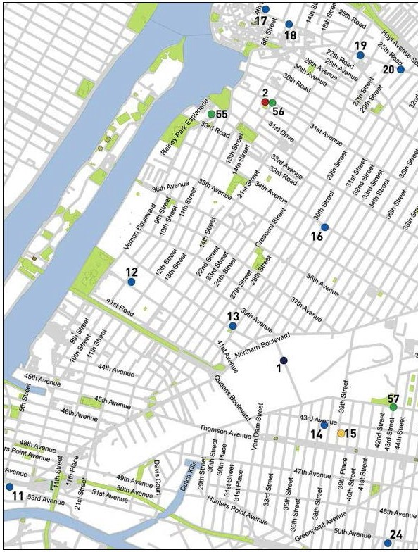

Neighborhood Guide to Food and Assistance -Western Queens Edition
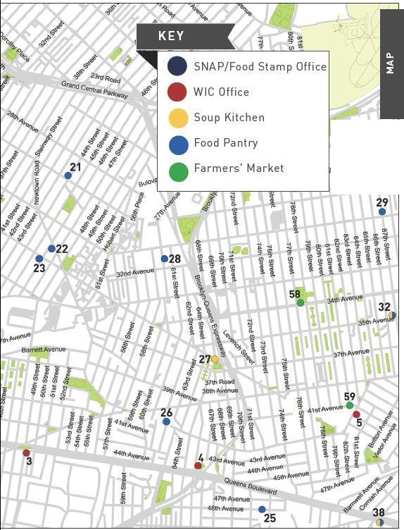

z•llif'veooe
As""l>ao,,,.""1
5 A.vef'l..ie

Neighborhood Guide to Food andAssistance - Western Queens Edition II
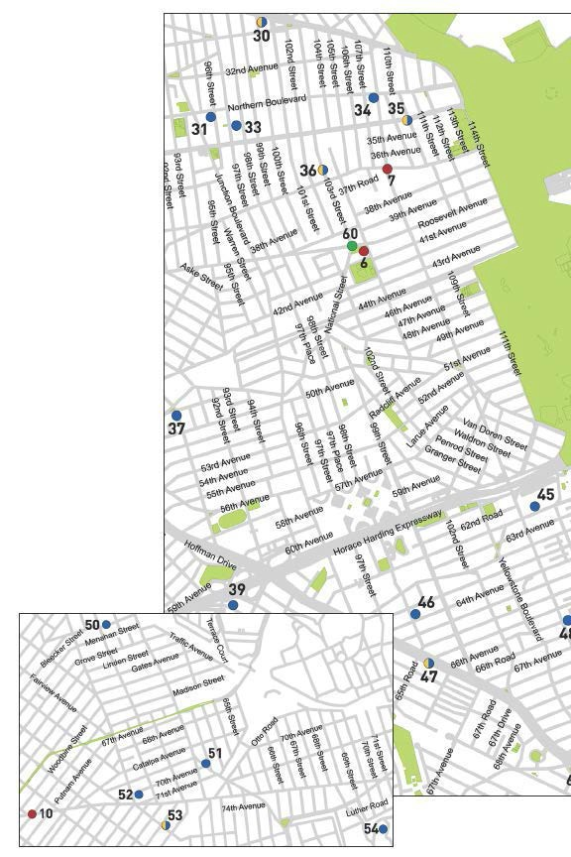
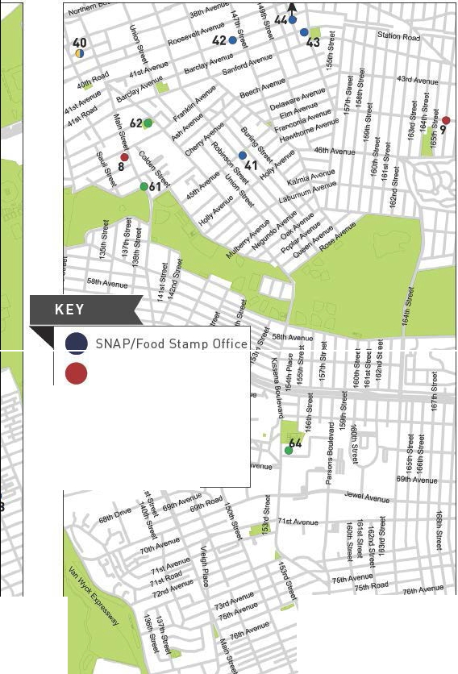

W IC Office

Sou p Kitche n

- Food Pa ntry

- Farme rs' M arket

16il\ l\Ot\\':enu•
3•
11.-"..,;
18\\i. 8\\'\ i:toad
49 •
Feel free to use t his space for your own notes.

IINe ighborhood Guide to Food and Assistance - Western Queens Edition


Neighbor hood Guide to Food and Assistance - Western Queens Edition II
OTHER ASSISTANCE
Additional organizations in your neighborhood that can as- sist you with matters other than food support.

MEDICAL CARE

elmhurst Hospital Center
79-01 Broadway, 11373
718 334 4000
Junction Medical Center
34-33 Junction Blvd., 11372
718 334 6150
ridgewood Medical Center
769 Onderdonk Ave., 11385
718 334 6190
Corona Health Center
104-04 Corona Ave., 11368
718 334 6100
Long Island City Health Center
36-11 21 St., 11106
718 482 7772
Woodside Health Center
50-53 Newtown Rd., 11377
718 334 6140

HEALTH INSURANCE

Affinity Health System
Information regarding health insurance, including enrollment in Medicaid, Medicare and other plans.
General Info 866 694 9809
41-46 Main St., Flushing 11355
37-06 74th St., Jackson Heights 11372

Neighborhood Guide to Food and Assistance - Western Queens edition
30

Provides specific and detailed assistance regarding a wide range of legal topics, including agencies that might be able to help you find an attorney to represent you in court.
LEGAL ASSISTANCE
The City Bar Justice Hotline
212 626 7383
Mon–Thu 9am-5pm, Fri 9am-1pm
Free, basic legal advice on a range of civil issues. Will not provide an attorney or assist with in-court representation.
X
MORE HELP
EMERGENCY NUMBERS

National Hunger Hotline 866 3-HUNGRY (866 348 6479)
NYC Hunger Hotline 866 888 8777 Police, Fire or Ambulance: 911 Emergency Shelter: 311
Homeless Hotline: 800 994 6494, 212 533 5151
Immigration Hotline: 212 419 3737, 800 566 7636
Center for Disease Control: 800 232 4636
Poison Control: 800 222 1222
AIDS Hotline: 800 541 AIDS, 800 233 7432 (Spanish)
Alcoholics Anonymous: 212 647 1680
Narcotics Anonymous: 212 929 6262
Gamblers Anonymous Hotline: 855 222 5542
Domestic Violence Hotline: 800 621 4673
Battered Women Hotline: 718 499 2151
Rape & Sexual Assault Hotline: 212 423 2140, 212 227 3000
Child Abuse Hotline: 800 342 3720
Runaway Hotline: 800 786 2929 (800 RUN AWAY)
Crime Victim Hotline: 212 577 7777, 800 689 4357
Suicide Hotline: 800 273 8255
National Crisis Line: 800 999 9999

Credits: Icons adapted from The Noun Project collection. Map data © OpenStreet- Map contributors.

Neighborhood Guide to Food and Assistance - Western Queens edition
31
WHAT AM I ELIG IBLE FOR ?

Use the chart below to see what programs may be available for you and your family.
e CD 0


PEOPLE WITH CHILDREN
e 0

PEOPLE WITHOUT CHILDREN
e a> 0

SENIOR CITIZENS
e CD 0

HOMELESS INDIVIDUALS

LEGAL IMMIGRANTS
e CD 0

UNDOCUMENTED IMMIGRANTS
() 0

A SNAP/ Food Stamp 0Groceries at Food Pantries WIC Packages
'1Benefits
School Breakfast & Lunch - Meals at Soup Kitchens
W Free Summer Meals for Children
/IP\ Meals at Senior Centers
\ii Home-delivered Meals
-IU:JN6ER

FREE
NYC
Have any suggestions on how to make this Guide better? Email gu ideslilhu ngerf reenyc.org.

